Department of Computer Science and Engineering (Data Science)
CSDS-A | Batch A1 (CSE - Data Science, Section A)
AI Health Insurance Assistance Using LLM + RAG
(PolicyLens)
S.No. | Student name | Roll / hall ticket no.
1 | G.PRANATHI | 23K91A6764
2 | CH.AISHWARYA | 23K91A6747
3 | BHAVANSH MANE | 23K91A6728
4 | B.DEEKSHITH | 24K95A6701
Under the guidance of: [GUIDE NAME], [DESIGNATION]
BLOCK DIAGRAMS
This document collects every design diagram of PolicyLens. Each diagram was drawn from the real code, database models and routes and is followed by a paragraph that explains it. The diagrams were generated by scripts/make_diagrams.py with matplotlib.
Table 1: Diagrams in this document
No. | Diagram | Shows
1 | System architecture | Layers: browser, React web app, FastAPI backend and services, local models, storage, Gemini API
2 | High-level workflow | Ten steps from upload to review
3 | DFD level 0 | Context: PolicyLens and its external entities
4 | DFD level 1 | Eight processes and nine data stores
5 | DFD level 2 | Expansion of the question-answering process
6 | Use-case diagram | Actors and their use cases
7 | Sequence diagram | Asking a question and opening a citation
8 | ER diagram | Twelve database tables
9 | UML class diagram | Domain entities, services and engine types
10 | Algorithm flowchart | Control flow of answer_question()

1 System Architecture
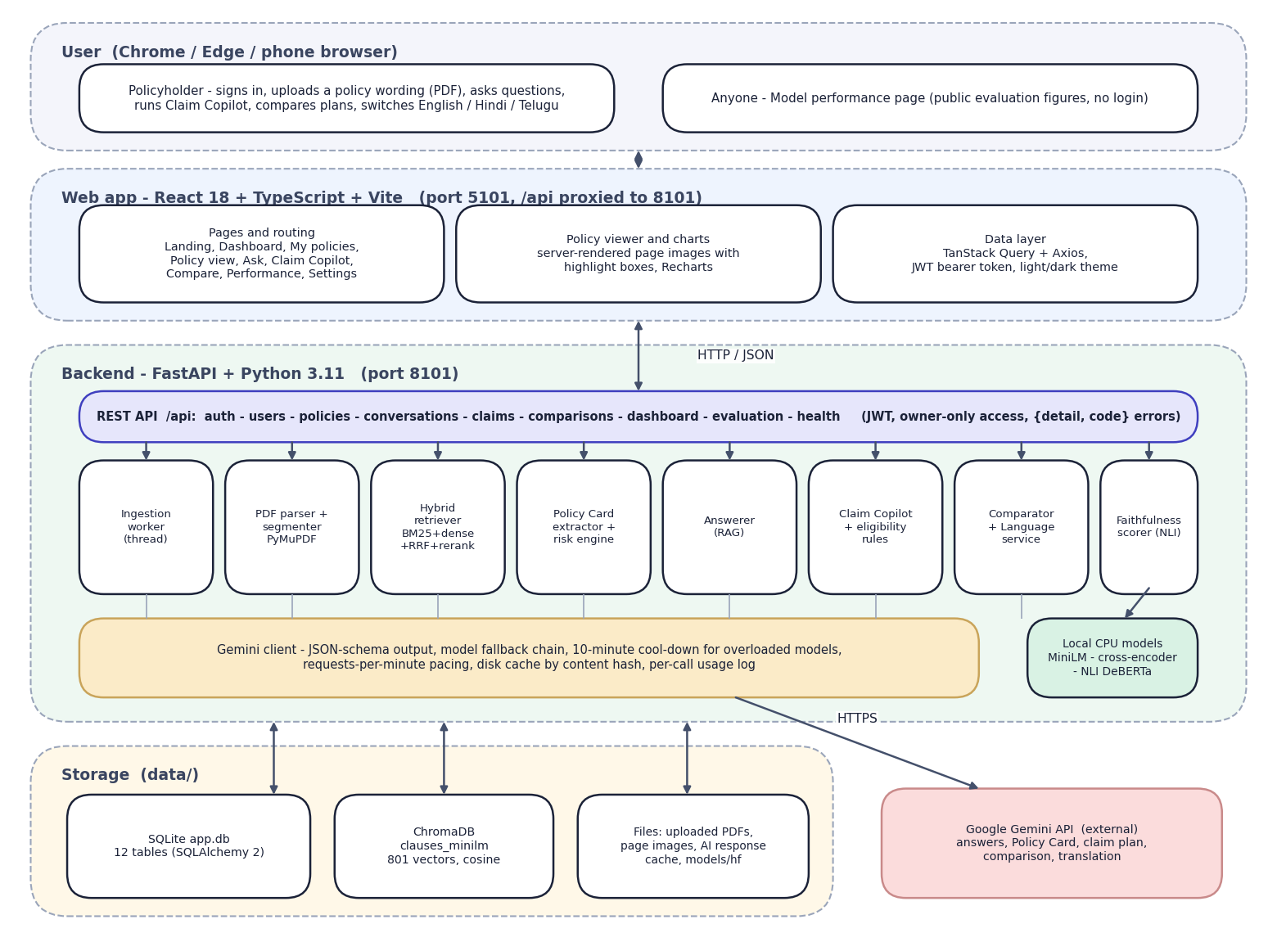
Fig. 1: System architecture of PolicyLens
The diagram shows five layers. At the top is the user's browser: a policyholder, and any visitor to the public Model performance page. Below it is the React web application, served by Vite on port 5101, which proxies every /api call to the backend. The backend is a FastAPI application on port 8101. Its REST layer exposes authentication, users, policies, conversations, claims, comparisons, the dashboard, evaluation and health endpoints, and passes work to eight services: the ingestion worker, the PDF parser and segmenter, the hybrid retriever, the Policy Card extractor with the risk engine, the answerer, Claim Copilot with the eligibility rules, the comparator with the language service, and the faithfulness scorer.
Every request to a language model goes through one Gemini client, which handles the JSON schema, the fallback chain, the pacing and the cache. Three small models run locally on the CPU. Storage is local: SQLite for records, ChromaDB for the clause vectors, and plain files for PDFs, page images and the response cache. The only external service is the Gemini API.

2 High-Level Workflow
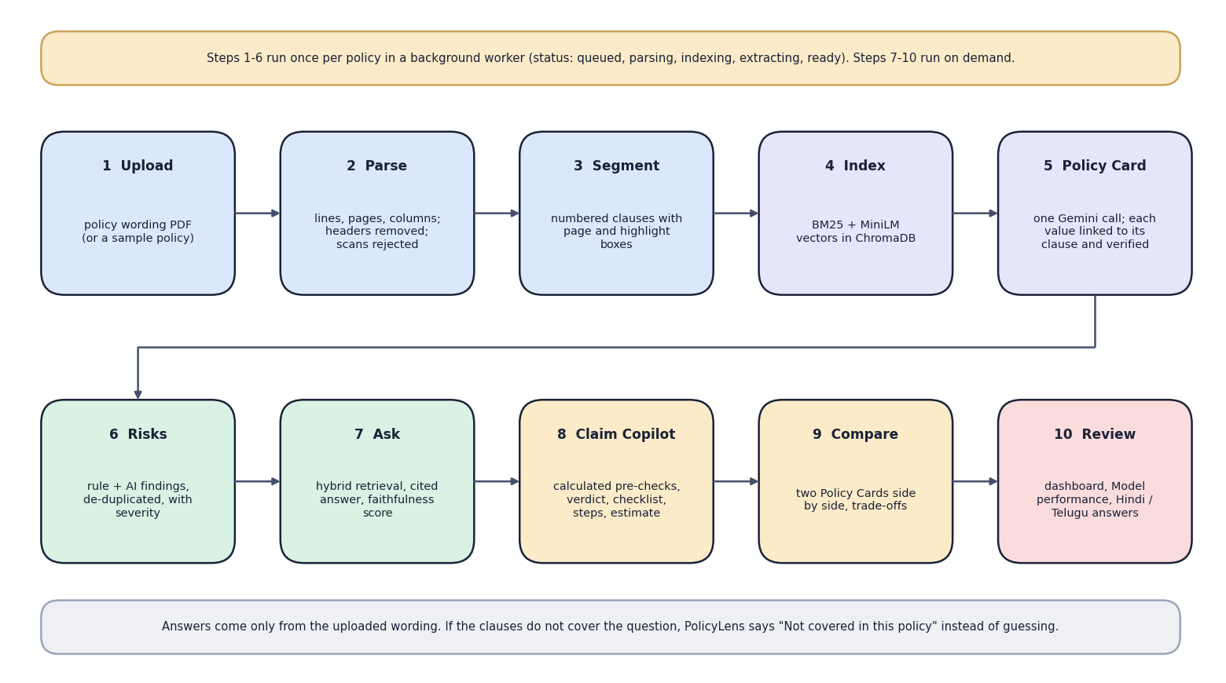
Fig. 2: High-level workflow
The ten steps fall into two groups. Steps 1 to 6 (upload, parse, segment, index, Policy Card, risks) run once per policy in a background worker whose status moves from queued to parsing, indexing, extracting and ready. Steps 7 to 10 (ask, Claim Copilot, compare, review) run on demand against a ready policy. The note at the bottom states the central rule of the system: if the wording does not cover a question, the assistant says so instead of guessing.

3 Data-Flow Diagram: Level 0
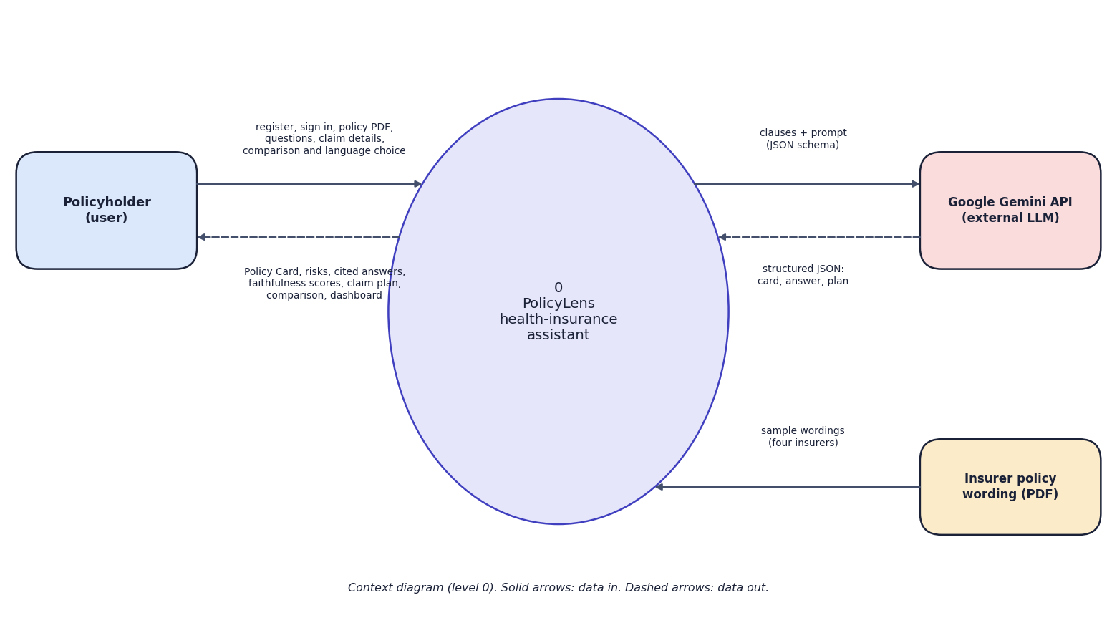
Fig. 3: Data-flow diagram, level 0 (context)
At the highest level PolicyLens is one process with three external entities. The policyholder sends credentials, policy PDFs, questions, claim details and comparison and language choices, and receives Policy Cards, risks, cited answers with faithfulness scores, claim plans and comparisons. The Gemini API receives clauses with a JSON schema and returns structured JSON. The insurer's policy wording is the input document, supplied either by the user or as one of four sample wordings.

4 Data-Flow Diagram: Level 1
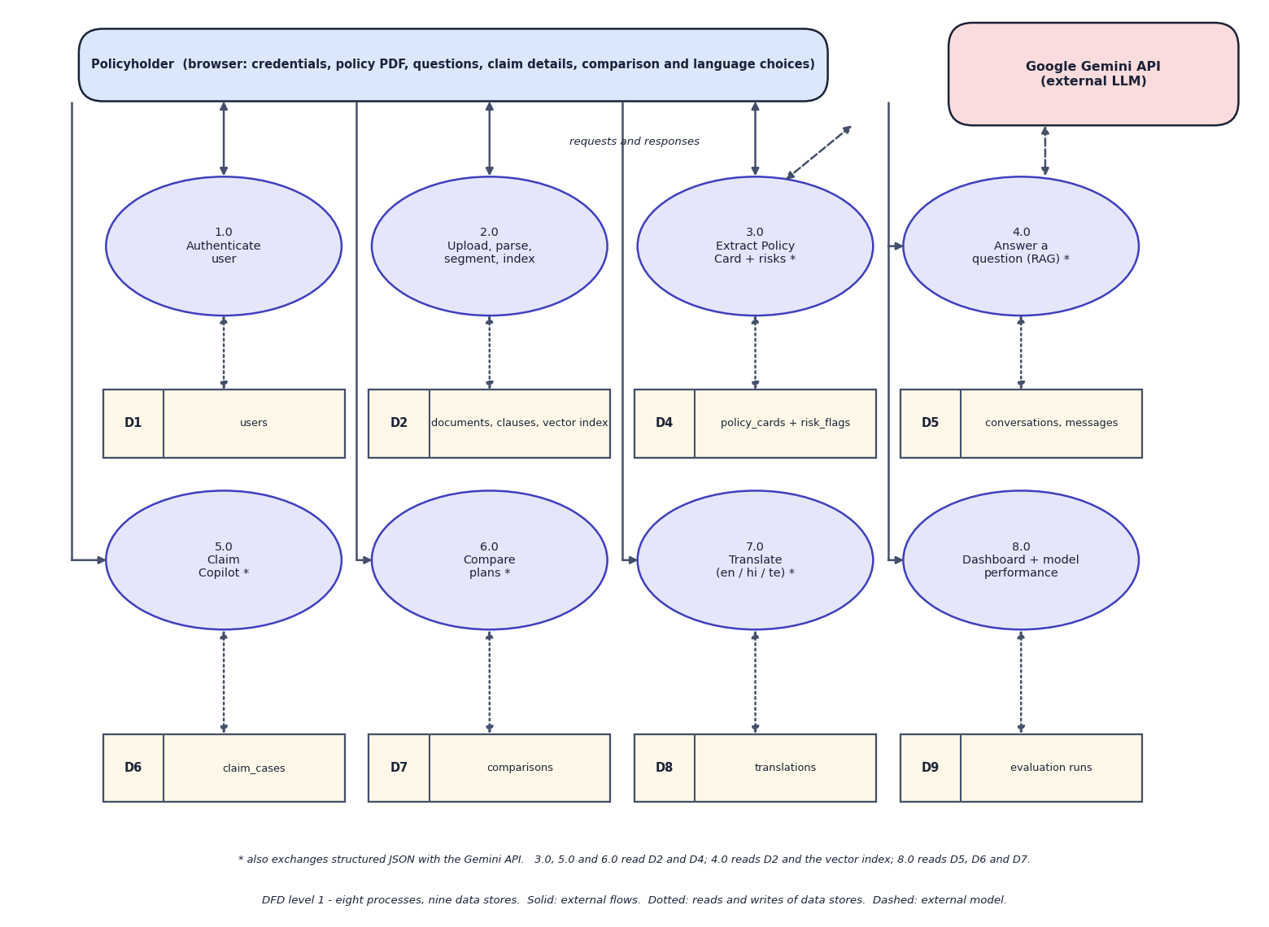
Fig. 4: Data-flow diagram, level 1
Level 1 splits PolicyLens into eight processes: authentication (1.0), upload, parse, segment and index (2.0), Policy Card and risk extraction (3.0), question answering (4.0), Claim Copilot (5.0), plan comparison (6.0), translation (7.0), and the dashboard with model performance (8.0). Nine data stores hold the users, the documents with their clauses and vector index, the cards and risk flags, the conversations and messages, the claim cases, the comparisons, the cached translations and the evaluation runs. Processes marked with an asterisk also exchange JSON with the Gemini API.

5 Data-Flow Diagram: Level 2
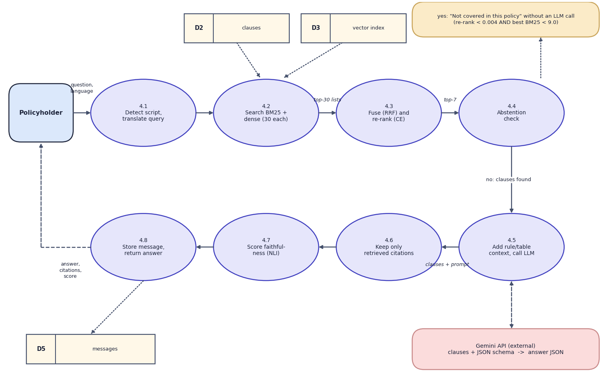
Fig. 5: Data-flow diagram, level 2: Answer a question (process 4.0)
Process 4.0 is expanded into eight steps that follow the code of answer_question(): detect the script and translate a Hindi or Telugu question into an English search query (4.1), search BM25 and the vector index for 30 candidates each (4.2), fuse the rankings and re-rank them with the cross-encoder (4.3), and check whether anything relevant was found (4.4). If nothing was, the answer "not covered in this policy" is returned without a model call. Otherwise the rule or table context is added and the model is called (4.5), citations to clauses that were not retrieved are dropped (4.6), the faithfulness score is computed (4.7), and the message is stored and returned (4.8).

6 Use-Case Diagram
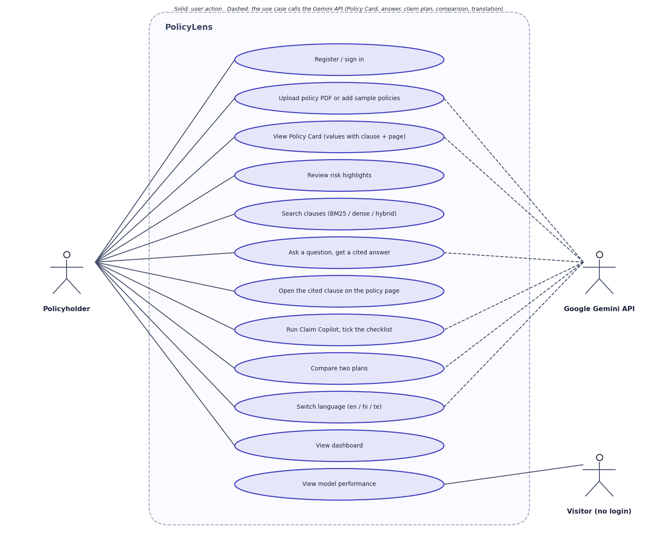
Fig. 6: Use-case diagram
The policyholder can register or sign in, upload a policy or add the samples, view the Policy Card, review risks, search clauses, ask questions, open a cited clause on its page, run Claim Copilot and tick its checklist, compare two plans, switch language and view the dashboard. A visitor who has not signed in can view the Model performance page. The Gemini API is an external actor used by the use cases that generate text: building the card, answering, claim planning, comparison and translation.

7 Sequence Diagram
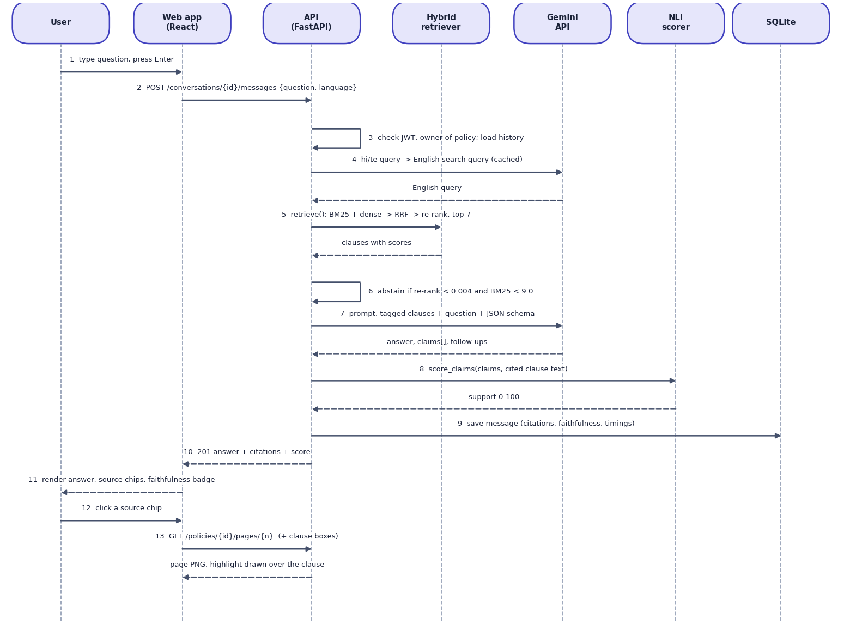
Fig. 7: Sequence diagram: asking a question and opening a citation
The sequence shows the main flow. The user submits a question; the web app posts it to the API, which checks the token and the ownership of the policy, translates the query if needed, retrieves the top clauses, and applies the abstention rule. If the model is called, the API sends the tagged clauses and the JSON schema, receives the answer and its claims, asks the NLI scorer for the support score, stores the message and returns the answer with its citations. When the user clicks a source chip the web app requests the page image, and the clause is highlighted on it.

8 Entity-Relationship Diagram
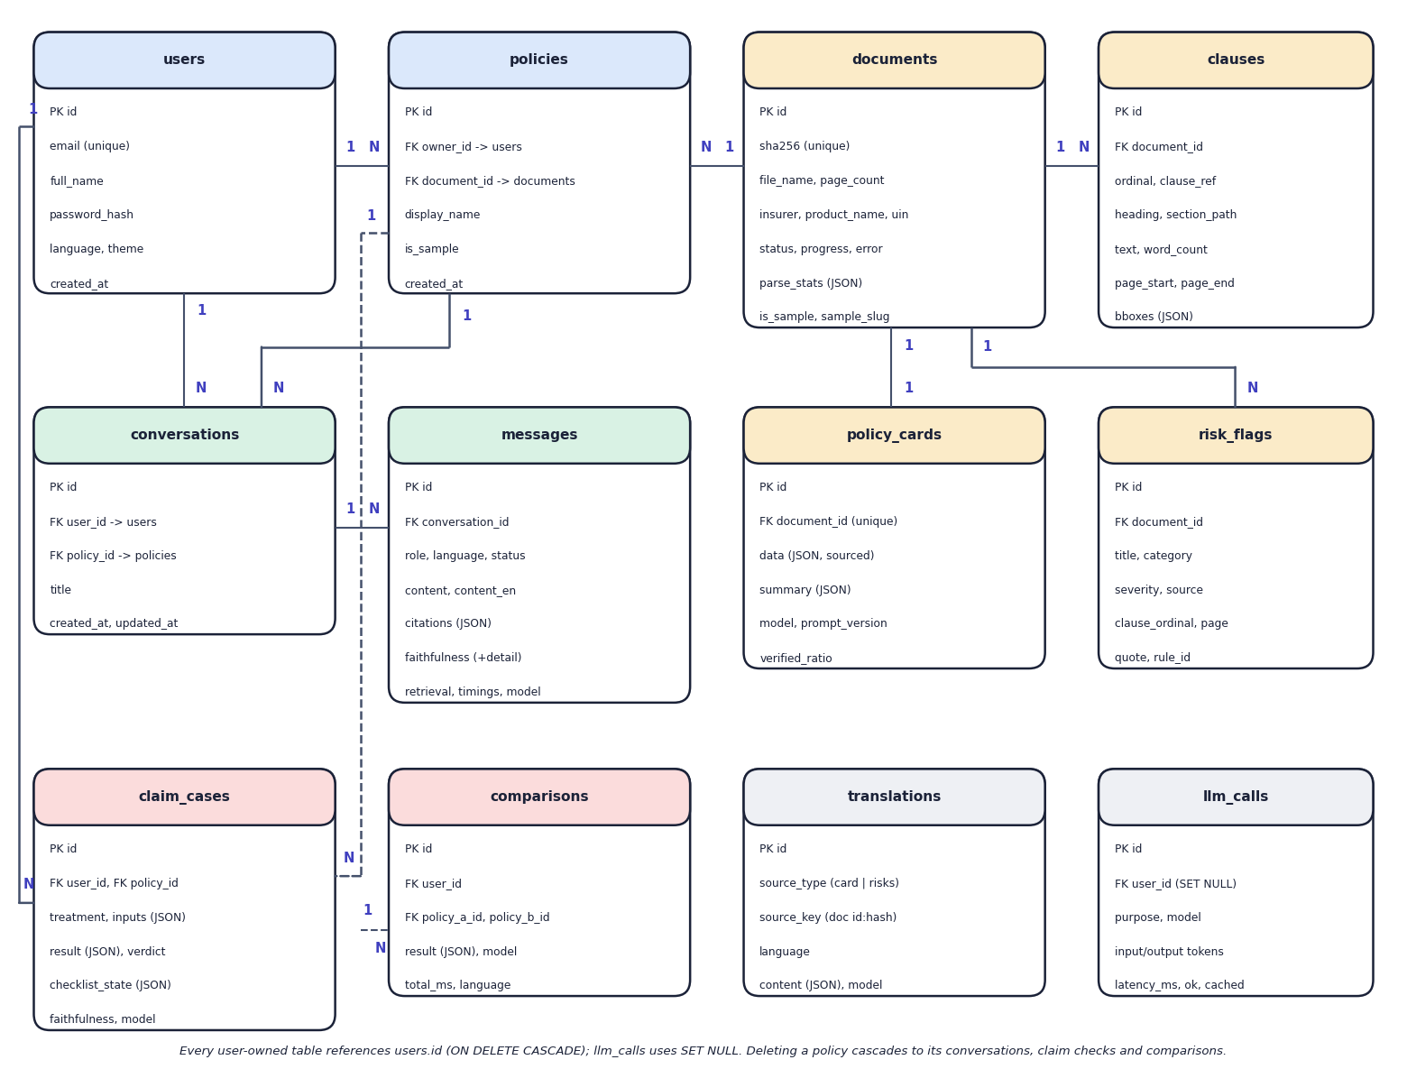
Fig. 8: Entity-relationship diagram (12 tables)
Twelve tables are created by SQLAlchemy in SQLite. A user owns policies; a policy points to a document, which is shared by content hash so that the same PDF is processed once even if two users upload it. A document has many clauses and risk flags and at most one Policy Card. Conversations belong to a user and a policy and contain messages. Claim cases and comparisons belong to a user and reference policies. Translations are cached by a key built from the document and a content hash, and the llm_calls table logs every model request.

9 UML Class Diagram
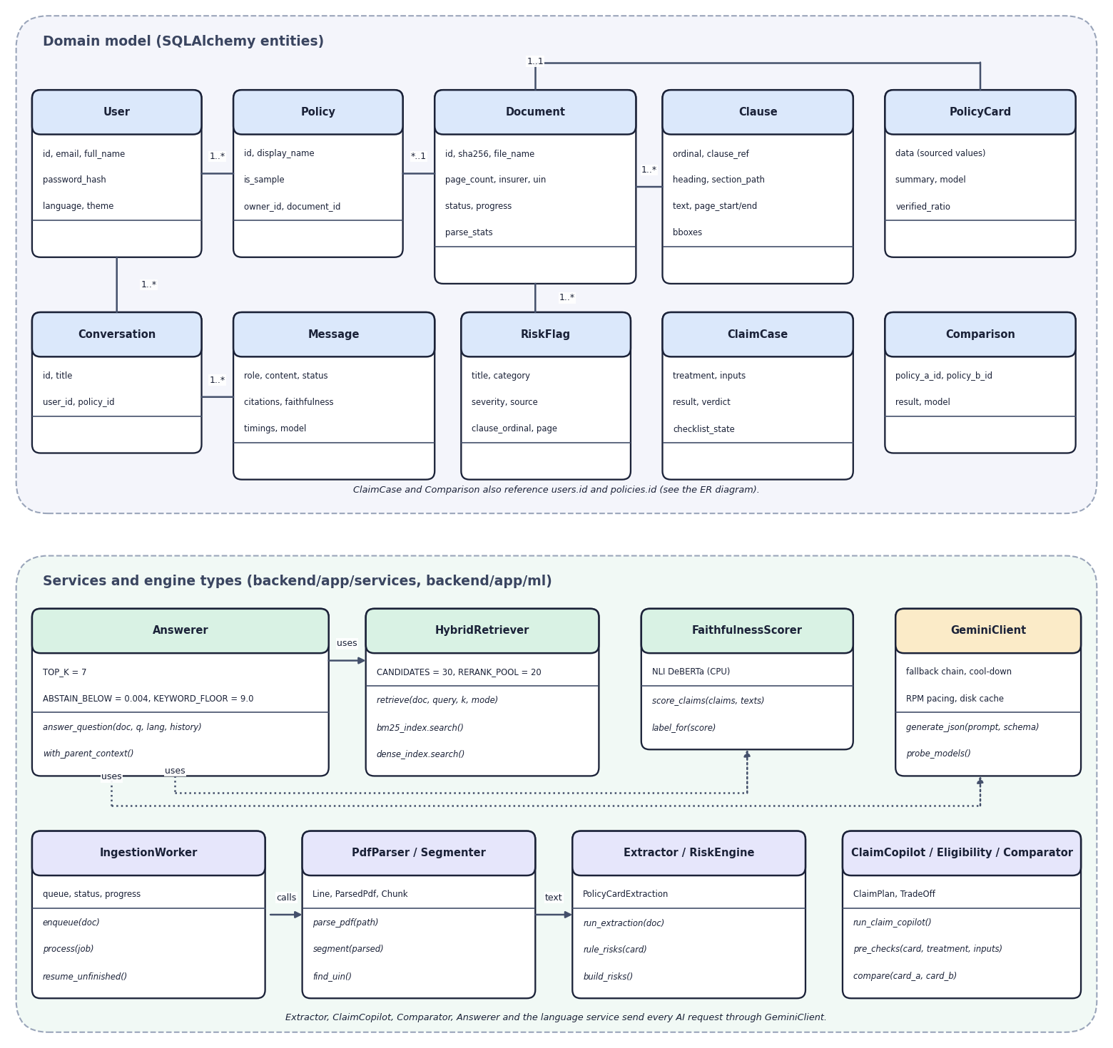
Fig. 9: UML class diagram
The upper part shows the domain entities with their main attributes and associations. The lower part shows the services and engine types with their key methods and constants: the answerer and its thresholds, the hybrid retriever, the faithfulness scorer, the Gemini client, the ingestion worker, the parser and segmenter, the extractor and risk engine, and the claim, eligibility and comparison services. Dotted arrows are dependencies; every AI request goes through the Gemini client.

10 Flowchart of the Core Algorithm
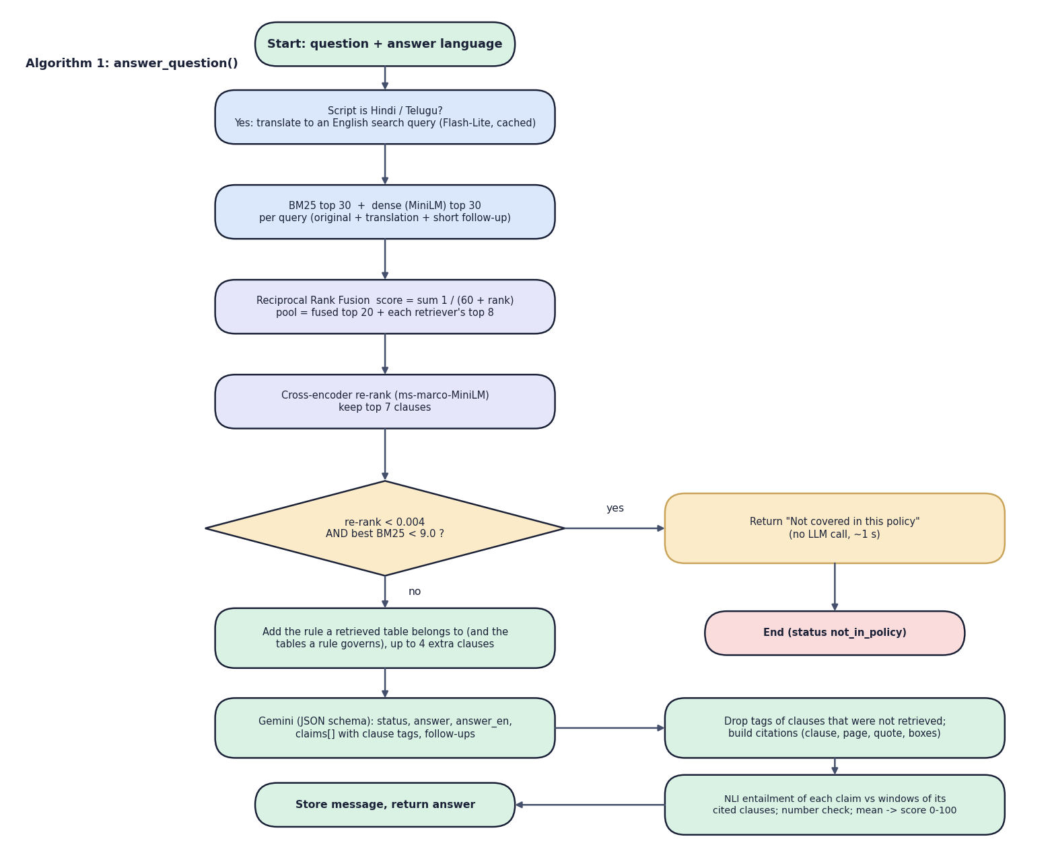
Fig. 10: Flowchart of the core algorithm, answer_question()
The flowchart follows the code of the answerer. After optional translation, BM25 and dense search each return 30 candidates; Reciprocal Rank Fusion combines them; the pool of the fused top 20 plus each retriever's top 8 is re-ranked by the cross-encoder, and the top 7 are kept. The decision diamond is the abstention rule. On the "no" path the rule or table that a retrieved fragment belongs to is added, Gemini is called with a JSON schema, uncited tags are dropped, citations are built, and each claim is scored by the NLI model before the message is stored.

